## 1. Use Separate Include Files

Use separate files for common content (referred to as 'include files') to keep your code modular and maintainable.  
  
|  |
| --- |
| **Project File** |
|  |
| **Db_Connect** |
|  |
| **Footer.inc** |
|  |
| **Header.inc** |
|  |
| **Nav.inc** |
|  |

## 2. External CSS Style Sheet

An external CSS style sheet must be created and used across all HTML pages to ensure consistent styling.

|  |
| --- |
| **Styles.CSS Page** |
|  |

## 3. CSS Validation

The external CSS file should be validated using the CSS validator available at https://jigsaw.w3.org/css-validator/#validate_by_input. A screenshot of the validation results should be saved and included in a document called 'Test.docx'.  
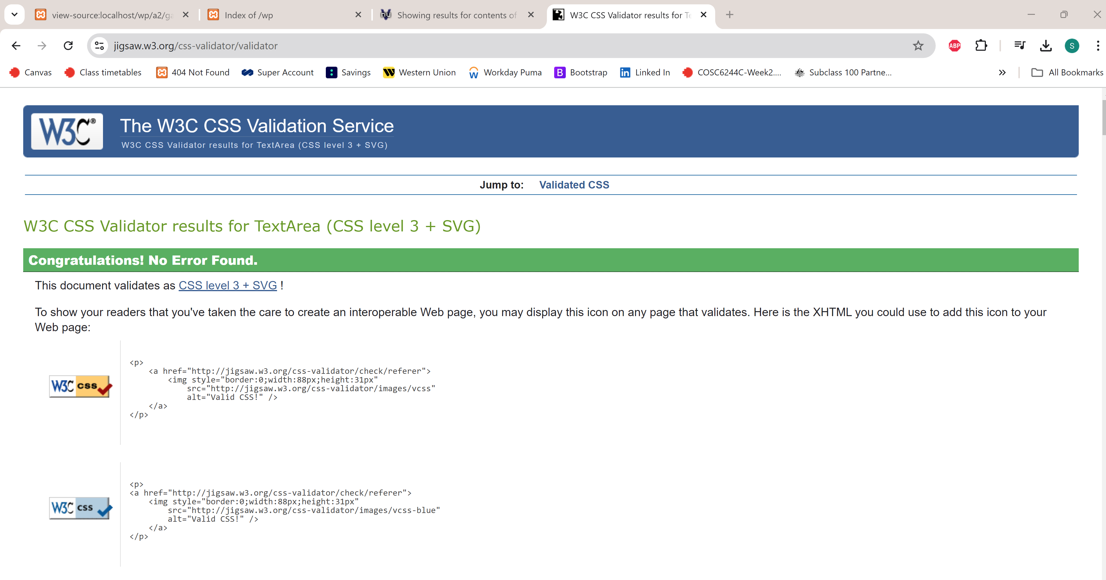

## 4. HTML Validation

The resulting HTML for each PHP page should be validated via https://validator.w3.org/#validate_by_input. A screenshot of each HTML page's validation should be saved and included in the 'Test.docx' file.

|  |
| --- |
| **Add-process HTML /CSS Validation** |
|  |
| **Add HTML /CSS Validation** |
|  |
| **Details HTML /CSS Validation** |
|  |
| **Gallery HTML /CSS Validation** |
|  |
| **Index HTML /CSS Validation** |
|  |
| **Pets HTML /CSS Validation** |
|  |

## 5. Page Demonstration

The resulting HTML for each PHP page should be validated via https://validator.w3.org/#validate_by_input. A screenshot of each HTML page's validation should be saved and included in the 'Test.docx' file.

|  |
| --- |
| **Add-process** |
|  |
| **Add** |
|  |
| **Details** |
|  |
| **Gallery** |
|  |
| **Index** |
|  |
| **Pets** |
|  |